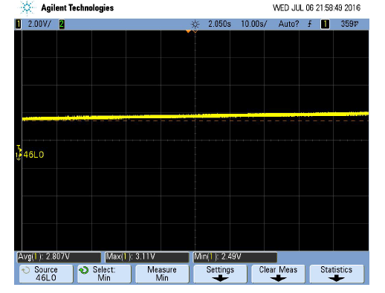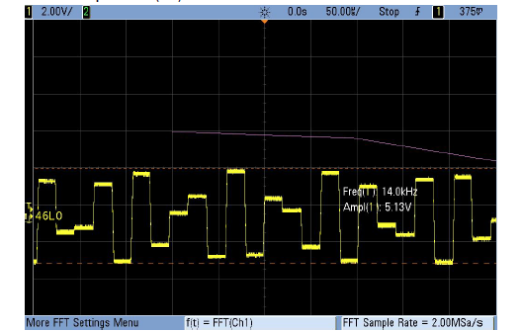

Figure : Set to off

Figure : Large wavelength with a 2 M Sample Rate

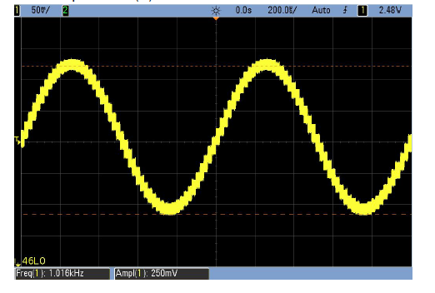

Figure : 1kHz Frequency with a 250mv output

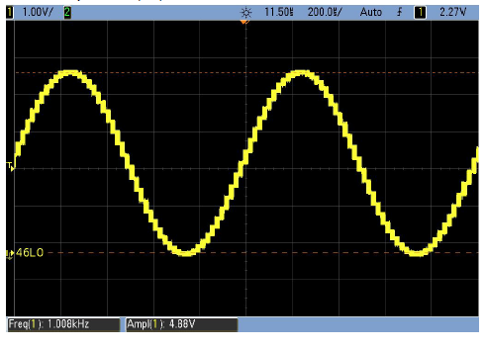

Figure : 5kHz with a full 5 volt output

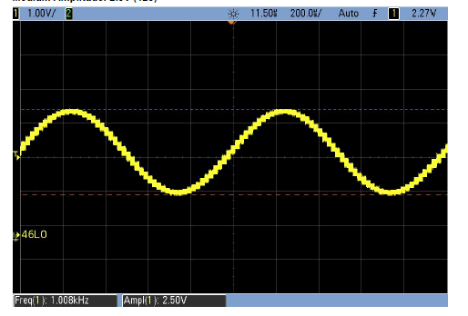

Figure : 1Khz frequency with 2.5 volts out